

FINAL YEAR PROJECT

2019

# HARDWARE DESIGN CONSIDERATIONS

CHRISTABEL ACQUAYE

DEPARTMENT OF COMPUTER ENGINEERING | KWAME NKRUMAH UNIVERSITY OF SCIENCE AND TECHNOLOGY

# INTRODUCTION

The electronic toll collection project considers various design considerations including, cost effectiveness, power consumption and accuracy. This report seeks to highlight the hardware design considerations used in the development of the project including clearly stating the components to be used both in the prototype and actual hardware design stage, power considerations, method of transmission chosen and so on.

# COMPONENTS TO BE USED

This section highlights the components selected and the reasons why they were selected despite the facts that different hardware components could have been used. For the prototyping stage the components considered includes;

List of sensors and modules considered for the proposed design

* ESP8266 Node MCU
* RC-522 13.56 MHz RFID Reader
* 5kg Servo motor
* Green and Red LEDs

## ESP 8266 NODE MCU

The ESP 8266 Node MCU is a development board which is USB TTL where Serial cables are a range of USB to serial converter cables which provide connectivity between USB and serial UART interfaces. It has 10 GPIO where every GPIO can be pulse width modulated.

NodeMCU has ESP-12 based serial WiFi integrated on board to provide GPIO, PWM, ADC, I2C and 1-WIRE resources at your finger tips， built-in USB-TTL serial with super reliable industrial strength CH340 for superior stability on all supported platforms. It is used in this project because;

* It is a cheaper option.
* It offers a more compatible development with C in Arduino, Javascript in Samrt.js, python in Micropython and so on.
* It offers enhanced functionality with a chip clock rate acceleration, a new Analog to Digital Converter(ADC)
* It also has a wide range of learning resources.
* It has an active community where different developers can share ideas on how to go about some developmental issues.

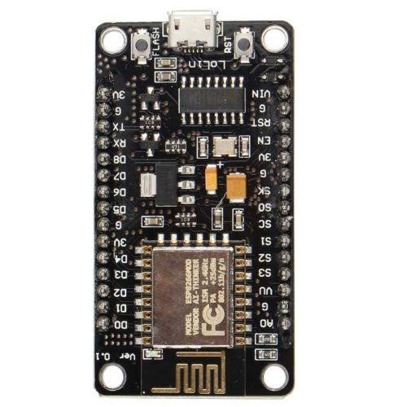

## RC-522 13.56 MHz RFID Reader

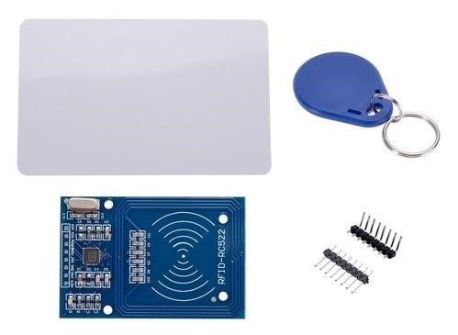

This low cost MFRC522 based RFID Reader Module is easy to use and can be used in a wide range of applications.

The MFRC522 is a highly integrated reader/writer IC for contactless communication at 13.56 MHz.

**Features:**

* MFRC522 chip based board
* Operating frequency: 13.56MHz
* Supply Voltage: 3.3V
* Current: 13-26mA
* Read Range: Approx 3cm with supplied card and fob
* SPI Interface
* Max Data Transfer Rate: 10Mbit / s
* Dimensions: 60mm × 39mm

## FUTUBA SERVO MOTOR

It operates on the principle of servomechanism (a principle that uses electromagnetism to convert electricity into accurate motion by employing negative feedback mechanism). [43] The main components include, a DC motor, a potentiometer, and an Integrated Circuit (IC). The potentiometer enables controlled motion by transmitting the existing location of the shaft. The DC motor is responsible for the movement of the shaft while the IC interprets the signal from the potentiometer and your microcontroller. To control this motor a mechanism known as pulse width modulation is employed to control the angular position of the shaft of the servo.

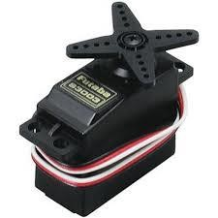

## LITHIUM POLYMER

A rechargeable Lithium Polymer (LiPo) battery with a nominal voltage 3.7V will be used as the main power supply.

* A Constant Voltage/Constant Current (CV/CC) charge IC is used for charging the battery.
* Protection circuit is used to safeguard against overdischarging and short circuit.

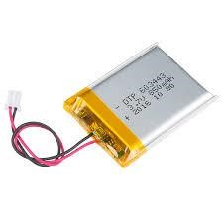

## GREEN AND RED LEDs

LEDs are used in most projects for illumination and indication purposes. As such for this project it is used for indicating the status of the transaction. When the transaction is successful, the green LED turns on while the red LED is turned off. However when the transcation is unsuccessful, the Red LED turns on.

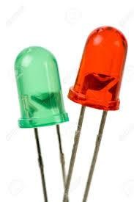

# HARDWARE BLOCK DIAGRAM

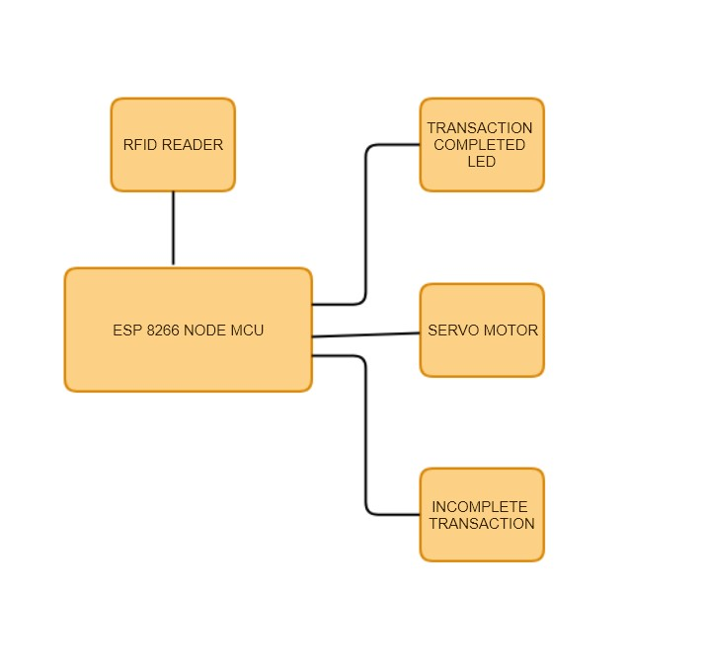

FRITZING DIAGRAM

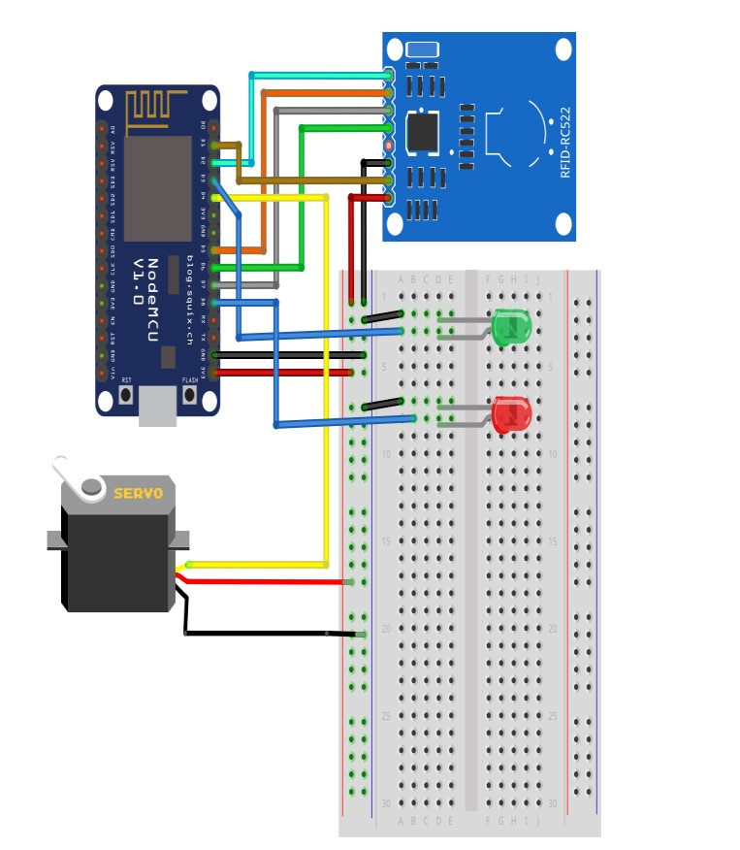

# SCHEMATIC DIAGRAM

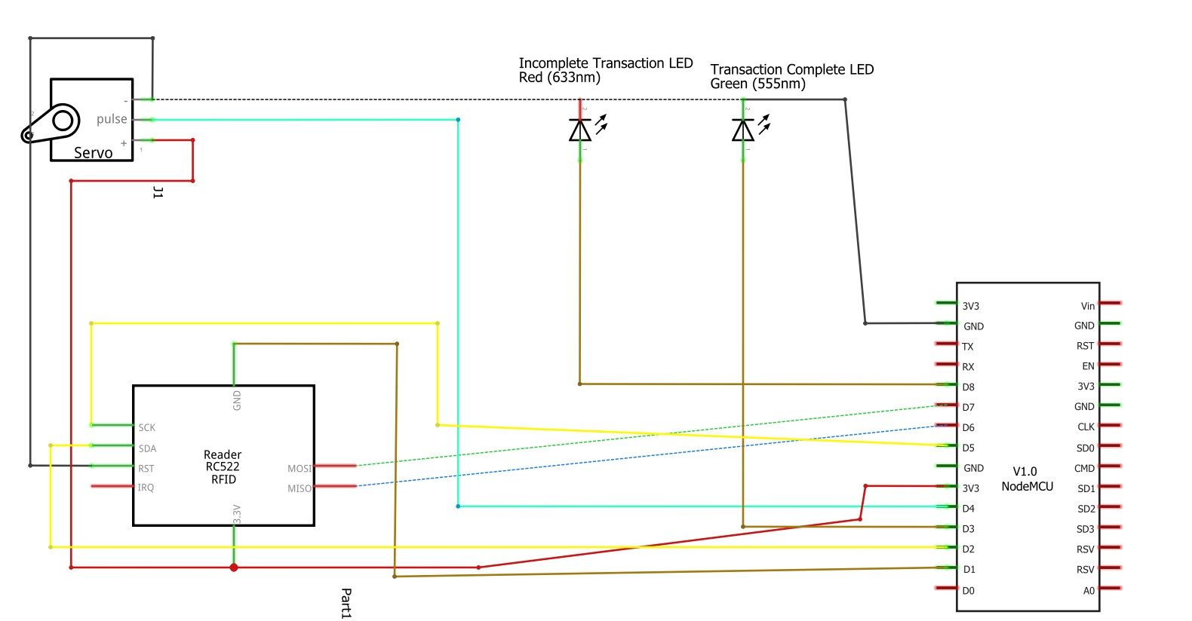

(Flow Chart of System)

# PROJECTED BUDGET FOR PROTYPE

|  |  |  |  |
| --- | --- | --- | --- |
| Hardware Components | Projected Cost For  1 Component | Quantity  Required | Total  Estimate |
| ESP 8266 Node MCU | ₵27.00 | 1 | ₵27.00 |
| RC-522 13.56 MHz RFID Reader | ₵45.00 | 2 | ₵90.00 |
| Futaba S3003 Servo | ₵50.00 | 1 | ₵50.00 |

**Total**₵167.00

# FLOWCHART OF HARDWARE SIMULATION

Enter details in Housing table starting in cell at right and in Entertainment table starting in cell G14. Next instr A27.

